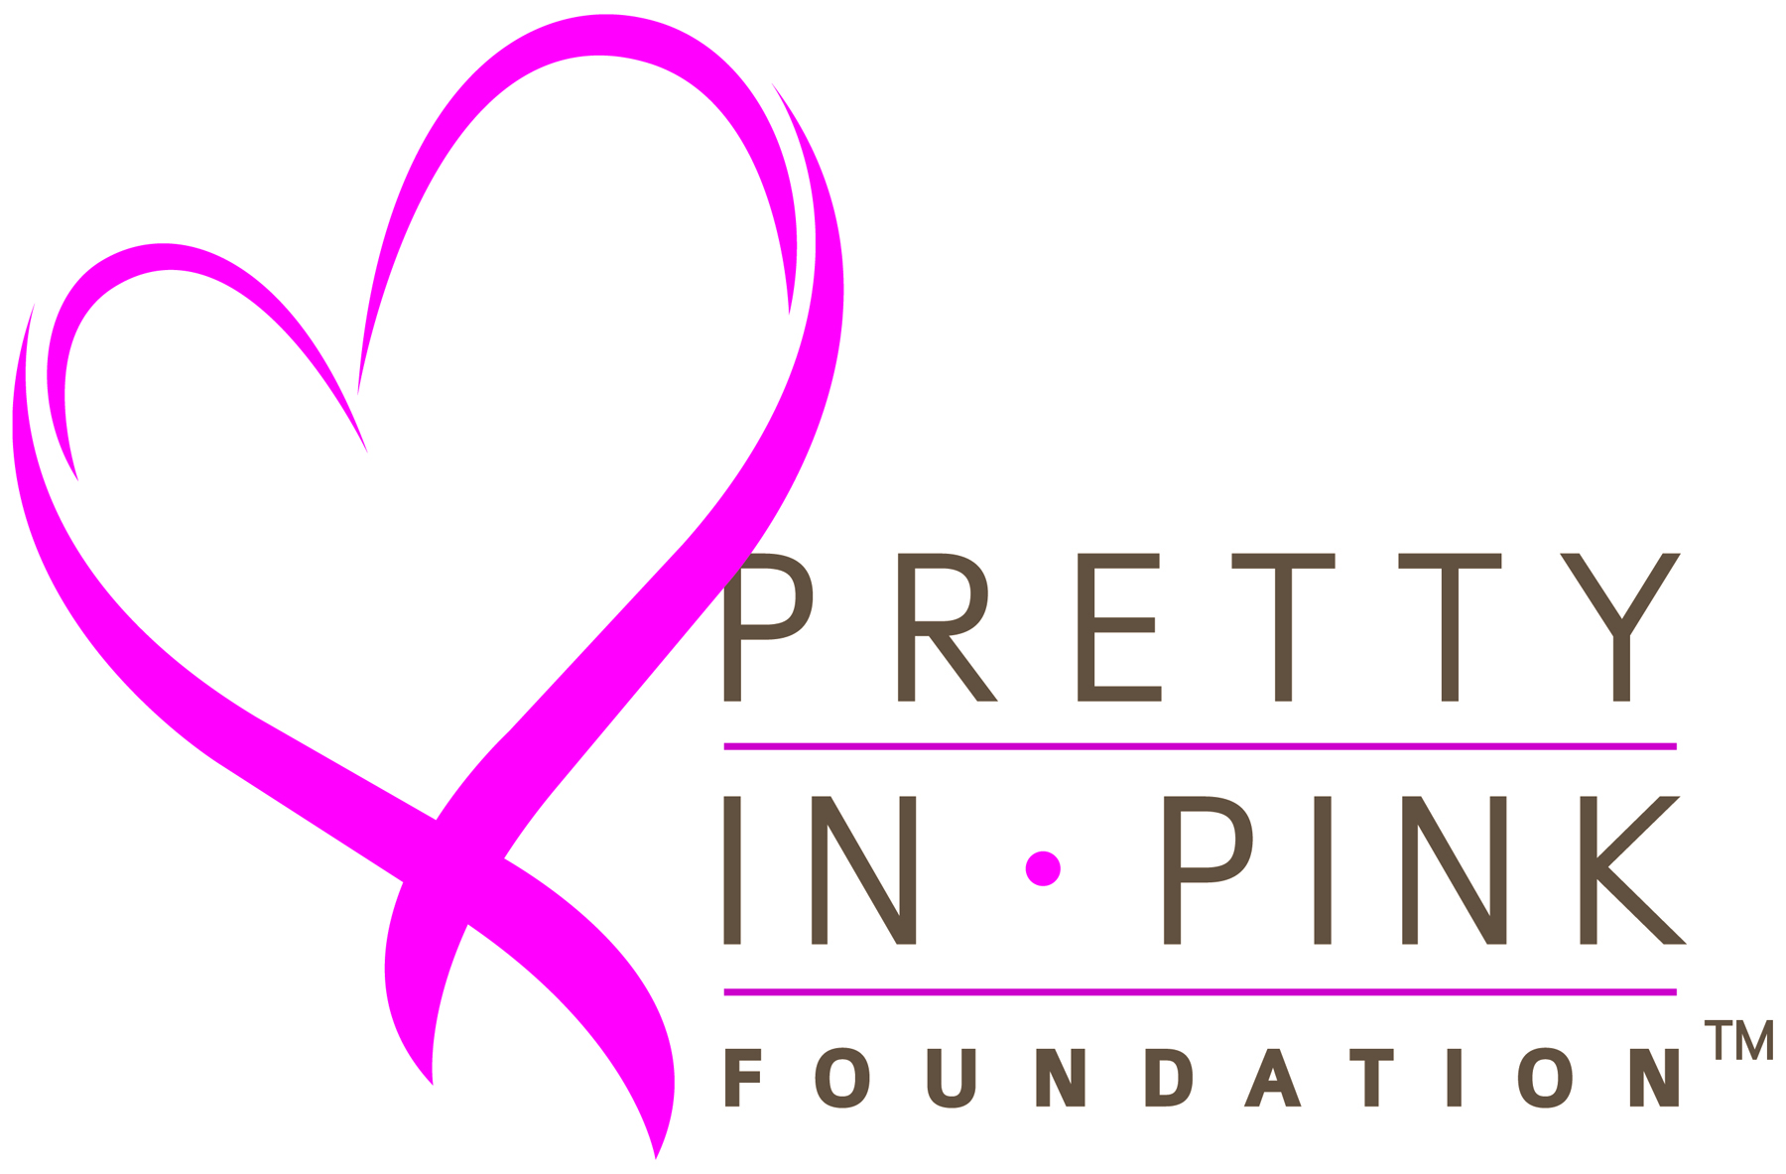 Patient Treatment Assistance
Guidelines & Requirement
Applicant Requirements
- North Carolina resident who has been diagnosed with breast cancer and is in any phase of active treatment
- Must be a US citizen
- Household income eligibility based on 2023 federal guidelines:

Family Size | Maximum Household Income | Family Size | Maximum Household Income
1 | $36,450 | 5 | $87,850
2 | $49,300 | 6 | $100,700
3 | $62,150 | 7 | $124,905
4 | $75,000 | 8 | $139,040

Financial Assistance for Those Who Qualify Includes for Assistance Toward Medical Expenses Associated With:
Surgical Consultations Surgery (excluding reconstruction) Chemotherapy Administration (excluding medications)
Radiation Therapy Co-Pays and Co-Insurance Premiums and Deductibles COBRA Premiums

Instructions:
- Complete and submit the Financial Assistance Request Form-Preliminary Request by mail or by fax
- Have your referring physician that is providing treatment:
    - Complete the Medical Referral Form
    - Attach your pathology report

The Medical Referral Form must be signed by a referring and treating physician, such as Surgeon, Oncologist, or Radiologist. Your social worker or patient navigator should be able to facilitate getting this form completed, and signed by the doctor. You can submit the Medical Referral Form and Pathology Report with your Financial Assistance Request Form; Or you can have your physician’s office send it directly to us by mail or fax.

After your Financial Assistance Request is screened and you meet initial eligibility, our Patient Resource Coordinator will contact to make sure all additional documentation is submitted. If you wish, you may go ahead and submit these documents with your initial Financial Assistance Request. These documents are needed to complete a full application.

These will include:
- Last 2 pay stubs or proof of unemployment. If your income is solely Social Security or Social Security Disability Income, then a copy of Social Security or Social Security Disability Income statement or letter.
- Most recent federal tax return (first 2 pages) or Schedule C if self-employed
- Your Story
- Medical/Health Information Release & Authorization
- Publicity Release
- Copy of driver’s license/ID OR utility bill
- If you are insured: copy of current Insurance, Medicare or Medicaid card (front and back)
- If you are uninsured: copy of Medicaid or social security disability rejection letters, if applicable

Notes
- Requests cannot be submitted for Medical Advisory Committee review until all required documents are received
- Approval may take up to 30 days
- Foundation grants assistance on a first-come, first-served basis to the extent that funding is available
- Medical Advisory Committee sets eligibility criteria and has final determination in all cases and reserves right to change program in its entirety or with respect to any applicant at any time with or without notice

Request received: _____________
PIPF Number: ______________
Pretty In Pink Foundation
Financial Assistance Request Form

This preliminary request will be used to determine if applicant qualifies for completion of full application which will be submitted to
the Medical Advisory Committee.

Request may be mailed or faxed to: Questions:
Pretty In Pink Foundation – Attn: Patient Financial Request Call: 919-532-0532
5171 Glenwood Ave- Suite 360 info@prettyinpinkfoundation.org
Raleigh, NC 27612
Fax: 919-977-6759

Date of Application: ________________
Applic
Applicant Name: ______________________________________________________________________________ ^{(Last)} (Last) (First) (MI)
DOB___________ Age_________ SSN(Last 4)___________

Home address:___________________________________________ City:___________________

County:______________ Zip:______________

Phone Number: ______________________________ Email:__________________________________

- Race (Re Race (circle one): American Indian or Alaska Native, Asian, Black/African American, Middle Eastern or North African,
Native or Native Hawaiian or Pacific Islander, White, Unknown or Other
- Ethnicity Ethnicity (circle one): Hispanic/Latino or Non-Hispanic/Latino

Insurance Information
1. Current Coverage: Medicaid ____ Medicare ____ Private health insurance ____ COBRA _____ Other__________
2. Insurance Provider: _____________________________ Co Pay(s): General ___________ / Specialty ____________
Insurance Monthly Premium _____________________ Deductible ________________ Deductible Met? Y N

3. Other Financial Assistance/ Charity Programs applied for:
Program __________________________________________________ Outcome __________________________
Program __________________________________________________ Outcome __________________________

Medical Information
Diagnosis: Date of Diagnosis:
Where are you currently in treatment (circle one) Surgery / Chemotherapy / Radiation Therapy/ Other_____

Hospital Contact: (Social Worker, Financial Counselor, Nurse Navigator)
Name Hospital / Clinic:
Phone: Fax or Email:

Financial Information Patient Spouse
1. Total # in household _______ Children under 18 ______ Monthly Income $_________ Monthly Income $_________
2. Employed? Y N Last worked: _________________ PT _______ FT _______ Casual ________
Employer:
Position/Title:
If not employed, source of income (circle): Unemployment Compensation Retirement Pension/ SSD/ SSI Family Support

Release of Information & Authorization

I have read Pretty In Pink Patient Treatment Assistance Guidelines & Requirements and I declare that the information furnished on this application form is true and correct to the best of my knowledge.

All information is reviewed by members of the Pretty In Pink Foundation Patient Treatment Assistance Medical Advisory Committee and is confidential. I understand that all applications will be reviewed on a case-by-case basis and final determination will be made by Medical Advisory Committee of Pretty In Pink Foundation.

I understand that any elective procedures (cosmetic surgery/breast implants) are not eligible for financial assistance.

I will apply for assistance (Medicare, Medicaid, and other charity programs), which may be available for payment for my hospital charges. If you receive other assistance, please provide this information to the Pretty In Pink Foundation.

I understand my request for financial assistance may only be for eligible expenses (surgery, chemotherapy (less medications), and radiation) as by agreement of participating physician. Requests may also be considered for health insurance premiums and COBRA premiums in situations where coverage is threatened for continuation.

I also understand that if my preliminary application is accepted, I will provide all other items pertaining to request. I understand my submission of full application does not guarantee granting of funding.

______________________________________ ________ ______________________________
Applicant’s Signature Date
Medical Referral
(To be completed by Medical Health Professionals Only)
Fax to Pretty In Pink Foundation: 919-977-6759

Patient Name:

Healthcare Professional:

Name of Practice/Clinic:

Contact name to discuss financial request:

Phone: Fax:

Diagnosis Information
Diagnosis (circle): Invasive Ductal or Lobular Carcinoma/ DCIS / Receptors: Estrogen, Progesterone, her-2 / Metastatic
Other: ______________

Date of Diagnosis: Stage at Diagnosis: _____________ Diagnosis Code: ______ _

Current Treatment / Treatment Plan (Please Attach Pathology Report)
Surgery
Chemotherapy
Radiation Therapy
Please indicate if other services may be required:

Please answer the following to help us review case as presented:
- Has patient applied for Medicaid/Medicare? Yes No
- Does your facility or health system offer financial assistance? Yes No
If yes, has patient completed application Yes No

Other physicians that will be participating in care:
Surgeon: Hospital / Clinic:
Oncologist: Hospital / Clinic:
Radiologist: Hospital / Clinic:

Please write any additional information or comments you may have concerning the applicant receiving financial assistance from
Pretty in Pink Foundation and why you are referring this patient.

Name of Referring Physician:

Signature of Referring Physician: Date:

AUTHORIZATION TO DISCLOSE HEALTH INFORMATION

I authorize Pretty In Pink Foundation to request, use, and disclose certain health care and billing information regarding my breast cancer diagnosis, treatment, and medical bills from and to the following:

________________________________________________________________________________________________________________
(Please list names of healthcare providers or healthcare facilities involved in your care on this line)
I understand that this authorization will expire 12 months after the date of execution. Information will be used or disclosed for the following purposes: to assist the Foundation in determining my eligibility for financial assistance, and if awarded assistance to pay grant funds toward eligible medical bills. Pretty In Pink Foundation will not receive payment or other remuneration from a third party in exchange for using or disclosing health information and will maintain privacy regarding personal health information.

I understand that if I fail to specify an expiration date or condition, this authorization is valid for the period needed to fulfill its purpose for up to one year, except for disclosures for financial transactions, wherein the authorization is valid indefinitely. I also understand that I may revoke this authorization at any time and that I will be asked to sign the Revocation Section on the back of this form. I further understand that any action taken on this authorization prior to the rescinded date is legal and binding.
I understand that my information may not be protected from re-disclosure by the requester of the information; however, if this information is protected by the Federal Substance Abuse Confidentiality Regulations, the recipient may not re-disclose such information without my further written authorization unless otherwise provided for by state or federal law.
I understand that if my record contains information relating to HIV infection, AIDS or AIDS-related conditions, alcohol abuse, drug abuse, psychological or psychiatric conditions, or genetic testing this disclosure will include that information. I also understand that I may refuse to sign this authorization and that my refusal to sign will not affect my ability to obtain treatment, payment for services, or my eligibility for benefits; however, if a service is requested by a non-treatment provider (e.g., insurance company) for the sole purpose of creating health information (e.g., physical exam), service may be denied if authorization is not given. If treatment is research-related, treatment may be denied if authorization is not given.
I further understand that I may request a copy of this signed authorization.

(Signature of Client) |  | (Date) |  | (Witness-If required)

(Signature of Personal Representative) |  | (Date) |  | (Personal Representative Relationship/Authority)
**********
NOTE: This Authorization was revoked on _________________________
REVOCATION SECTION

I do hereby request that this authorization to disclose health information of ___________________________ (Name of Client) signed by ________________(Name of Person Who Signed Authorization) on (Date of Signature) be rescinded, effective _______________________ (Date). I understand that any action taken prior to the rescinded date is legal and binding.

Signature of Client ____________________________ Date_________________________

Signature of Witness ____________________________ Date __________________

VERBAL REVOCATION

I do hereby attest to the verbal request for revocation of this authorization by _________________________________________ (Name of Client or Personal Representative) on __________ (Date) The client or his personal representative has been informed that any action taken on this authorization prior to the rescinded date is legal and binding.

Signature of Staff ________________________________ Date _______________________

Signature of Witness _____________________________ Date _________________________

Name:
PIPF Number:

Your Story
(Optional)

The Pretty In Pink Foundation Board has no way of knowing you except through this application.
Please use this space to share your story or additional information, so that we might better understand your need for assistance.

___________________________________________________________________________________

___________________________________________________________________________________

___________________________________________________________________________________

___________________________________________________________________________________

___________________________________________________________________________________

___________________________________________________________________________________

___________________________________________________________________________________

___________________________________________________________________________________

___________________________________________________________________________________

___________________________________________________________________________________

___________________________________________________________________________________

___________________________________________________________________________________

___________________________________________________________________________________

___________________________________________________________________________________

___________________________________________________________________________________

___________________________________________________________________________________

___________________________________________________________________________________

___________________________________________________________________________________

Publicity Release of Information

Pretty In Pink Foundation asks for your permission to share your story with others to help raise public awareness of the Foundation, communicate to donors and the community to support the cause, and inform breast cancer patients, healthcare providers, and others about the Foundation’s services.

Yes, I allow Pretty In Pink Foundation to use:

First Name
All or part of your story (anonymously)
Services received from the Foundation
Use of photo (if provided)
Quote

No, I do not give permission for Pretty In Pink Foundation to use my personal information or images in publications, general media or materials.

I understand I have the right to revoke my authorization at any time by contacting Pretty In Pink Foundation at info@prettyinpinkfoundation.org or at the below address. Revocation will be effective upon receipt and affects disclosure moving forward and is not retroactive.

I understand that my approval or denial of permission will in no way affect the assistance provided to me by the Foundation.

I understand that information disclosed may be subject to redisclosure and may no longer be protected by Health Insurance Portability and Accountability Act (HIPAA) and the Health Information Technology for Economic and Clinical Health (HITECH) Act.

I understand that Pretty In Pink Foundation owns all marketing and outreach materials as released by me, and I hereby release rights to these items. I understand I will not be compensated for the use of the released information. I have read and understand the terms of this release. I certify that I am of legal age, 18 years of age or older.

Name (printed): Date:

Signature:

Please Mail or Email the Completed Form To:

Pretty In Pink Foundation
5171 Glenwood Avenue, Suite 360
Raleigh, NC 27612
Email info@prettyinpinkfoundation.org

